FALL 2026–2027 • THEORY + LAB

Bresenham's Midpoint
Line Drawing Algorithm
Complete step-by-step instructor handout | Derivation • Decisions • Solved mathematics • Pseudocode • C++/OpenGL
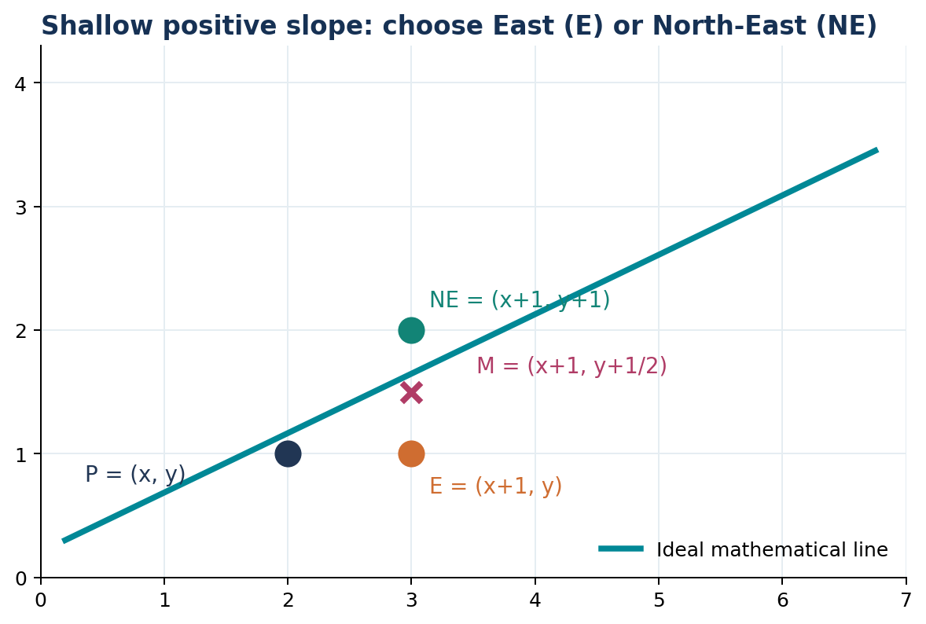

Learning objectives
- Explain why raster screens need line drawing algorithms and how the midpoint test chooses a pixel.
- Derive the initial decision value d₀ = 2Δy − Δx and both E/NE update rules for 0 ≤ m ≤ 1.
- Solve shallow- and steep-slope numerical problems with an iteration table.
- Implement the algorithm in C++ using OpenGL/FreeGLUT; recognize all-octant extensions.
TEACHING NOTE Begin by showing the two candidate pixels and the midpoint. Only introduce equations after students understand the geometric choice.

1 Background: pixels, slope, and incremental decisions
A straight line consists of infinitely many continuous points, but the display is a discrete grid of pixel centres. Rasterization chooses which discrete pixels best represent the ideal geometric line.
Δx = x₂ − x₁ Δy = y₂ − y₁ m = Δy / Δx (when Δx ≠ 0)
For a shallow positive slope, 0 ≤ m ≤ 1, advance one column in x at every iteration. The next pixel must be either East (E) or North-East (NE).
E = (x + 1, y) NE = (x + 1, y + 1)
M = (x + 1, y + 1/2)
If the ideal line passes above midpoint M, choose NE; if below M, choose E. If it passes exactly through M, either candidate is equally close, so the implementation requires a consistent tie rule. The supplied slides choose E when the decision is zero.
TEACHING NOTE Do not claim Bresenham measures the full Euclidean distance to each candidate. For this case it compares an implicit line function at their midpoint.

2 Derive the implicit line function
Starting with the equation used in the slides:
y = mx + B and m = Δy / Δx
Substitute the slope, multiply both sides by Δx, then bring every term to the left:
y = (Δy/Δx)x + B
Δx · y = Δy · x + BΔx
Δy · x − Δx · y + BΔx = 0
Write the result as F(x,y) = ax + by + c, where:
a = Δy b = −Δx c = BΔx
Thus F(x,y) = Δy·x − Δx·y + BΔx. Every exact point of the ideal line satisfies F(x,y) = 0. Its sign identifies which side of the line contains the midpoint.

3 Derive the initial decision parameter (shallow slope)
At the starting point P₀=(x₀,y₀), the first decision is evaluated at the midpoint between the E and NE candidate pixels:
M₀ = (x₀ + 1, y₀ + 1/2)
d₀(unscaled) = F(M₀)
= a(x₀ + 1) + b(y₀ + 1/2) + c
= (ax₀ + by₀ + c) + a + b/2
Because P₀ lies on the mathematical line:
F(x₀,y₀) = ax₀ + by₀ + c = 0
d₀(unscaled) = a + b/2 = Δy − Δx/2

Why multiply everything by 2?
The sign—not the magnitude—determines the selected pixel. Multiplying by positive 2 preserves the sign and eliminates the one-half, giving an entirely integer-valued initial decision for integer endpoints.
2 × (Δy − Δx/2) = 2Δy − Δx
FINAL SCALED START VALUE: d₀ = 2Δy − Δx
TEACHING NOTE This is the “multiplying part” to emphasize: 2 is a positive scaling factor that removes 1/2. It does NOT mean the midpoint position itself changes.

4 Derive the E update
When E is chosen, the current pixel moves from (x,y) to (x+1,y); the next midpoint becomes (x+2, y+1/2).
dnew − dold = F(x+2, y+1/2) − F(x+1, y+1/2)
= a = Δy (unscaled)
Because the stored parameter is twice the unscaled one:
IF E IS CHOSEN: dnew = dold + 2Δy
Coordinates: (x,y) → (x+1, y)

5 Derive the NE update
When NE is chosen, the current pixel moves from (x,y) to (x+1,y+1), so the next midpoint becomes (x+2, y+3/2).
dnew − dold = F(x+2, y+3/2) − F(x+1, y+1/2)
= a + b = Δy − Δx (unscaled)
IF NE IS CHOSEN: dnew = dold + 2(Δy − Δx)
Coordinates: (x,y) → (x+1, y+1)

6 Core algorithm: 0 ≤ m ≤ 1 and x₂ > x₁
This is the original positive, shallow-slope case taught in the supplied slides. Define Δx=x₂−x₁ ≥ 0, Δy=y₂−y₁ ≥ 0, with Δy ≤ Δx.
Decision | Pixel chosen | Coordinates after move | Update d
d > 0 | NE | x ← x+1; y ← y+1 | d ← d + 2(Δy − Δx)
d ≤ 0 | E | x ← x+1; y unchanged | d ← d + 2Δy

- Calculate Δx and Δy, checking that the assumptions hold.
- Initialize x=x₁, y=y₁, and d=2Δy−Δx.
- Plot the initial pixel (x₁,y₁).
- For each of the next Δx columns, inspect the current d.
- Choose NE if d>0; otherwise choose E. Update coordinates and d.
- Plot the new pixel. Stop when the final endpoint is reached.

Language-independent pseudocode
BRESENHAM_SHALLOW(x1, y1, x2, y2)
dx = x2 - x1
dy = y2 - y1
// Preconditions: dx > 0 and 0 <= dy <= dx
d = 2*dy - dx
x = x1; y = y1
PLOT(x, y)
while x < x2
if d > 0
x = x + 1; y = y + 1
d = d + 2*(dy - dx) // NE
else
x = x + 1
d = d + 2*dy // E
PLOT(x, y)

Three facts students should memorize
Start d: 2Δy − Δx
E: d + 2Δy
NE: d + 2(Δy − Δx)

7 Worked example from the lecture: (4,5) → (7,7)
First compute Δx=7−4=3 and Δy=7−5=2, so m=2/3 (shallow).
d₀ = 2(2) − 3 = 1
Straight E increment = 2Δy = +4
Diagonal NE increment = 2(Δy−Δx) = 2(2−3) = −2
From | d before | Choice | To / plotted pixel | d after
(4,5) | 1 (>0) | NE | (5,6) | 1−2 = −1
(5,6) | −1 (≤0) | E | (6,6) | −1+4 = 3
(6,6) | 3 (>0) | NE | (7,7) | endpoint

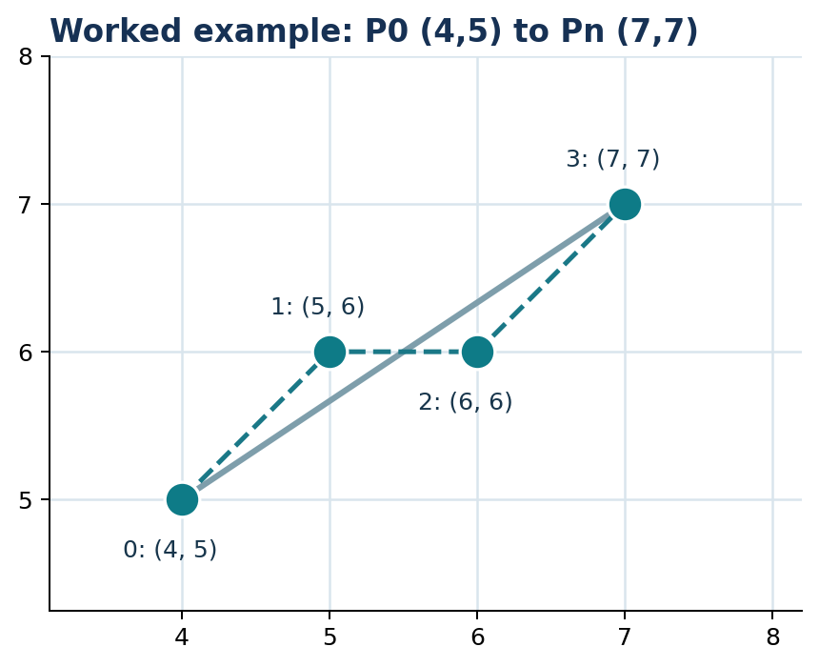
PIXEL SEQUENCE: (4,5), (5,6), (6,6), (7,7)

8 Longer shallow-slope example, including a tie
Example: draw the line from (2,3) to (10,7). This is an added instructor practice problem, not the lecture slide example.
Δx=10−2=8 Δy=7−3=4 m=4/8=0.5
d₀=2(4)−8=0 E increment: +8 NE increment: −8
The source deck uses d ≤ 0 ⇒ E. Hence, the first decision at d=0 selects E.
Step | Current pixel | d before | Decision | Next pixel | d after
1 | (2,3) | 0 | E | (3,3) | 8
2 | (3,3) | 8 | NE | (4,4) | 0
3 | (4,4) | 0 | E | (5,4) | 8
4 | (5,4) | 8 | NE | (6,5) | 0
5 | (6,5) | 0 | E | (7,5) | 8
6 | (7,5) | 8 | NE | (8,6) | 0
7 | (8,6) | 0 | E | (9,6) | 8
8 | (9,6) | 8 | NE | (10,7) | end

PIXELS: (2,3), (3,3), (4,4), (5,4), (6,5), (7,5), (8,6), (9,6), (10,7)
TEACHING NOTE Ask students why two correct rasterizers may disagree on a tie. It is the documented tie policy, not necessarily a faulty derivation.

9 Steep positive slope: m > 1
When Δy > Δx ≥ 0, advance by one row each time. The candidates are N=(x,y+1) and NE=(x+1,y+1). The source deck states the following integer decision rules.
INITIAL: d₀ = 2Δx − Δy
Decision | Chosen pixel | New coordinates | Update d
d > 0 | NE | x ← x+1; y ← y+1 | d ← d + 2(Δx − Δy)
d ≤ 0 | N | x unchanged; y ← y+1 | d ← d + 2Δx

Why the formula swaps Δx and Δy: y is now the dominant coordinate, so the same midpoint reasoning is applied after exchanging the horizontal and vertical axes.

Full mathematical derivation for the steep case
For a steep, rising line, define an implicit function with the sign chosen so that positive selects NE:
G(x,y) = Δx(y−y₁) − Δy(x−x₁)
At a current pixel (x,y), N=(x,y+1) and NE=(x+1,y+1). Their midpoint is (x+1/2,y+1). At the initial endpoint, G(x₁,y₁)=0:
d₀(unscaled) = G(x₁+1/2, y₁+1) = Δx − Δy/2
Multiply by positive 2: d₀ = 2Δx − Δy
If N is selected, the next midpoint moves up one row; G changes by +Δx. If NE is selected, that next midpoint moves one column right and one row up; G changes by (Δx−Δy). Scale both changes by 2:
N: dnew = dold + 2Δx
NE: dnew = dold + 2(Δx − Δy)

10 Fully solved steep-slope example
Draw the line from (2,2) to (4,7). This is an instructor expansion of the source lecture’s steep-slope rules.
Δx=4−2=2 Δy=7−2=5 m=5/2=2.5 > 1
d₀=2(2)−5=−1
N increment = +2Δx = +4
NE increment = 2(Δx−Δy) = 2(2−5) = −6
Step | From | d before | Choice | Next pixel | d after
1 | (2,2) | −1 | N | (2,3) | −1+4=3
2 | (2,3) | 3 | NE | (3,4) | 3−6=−3
3 | (3,4) | −3 | N | (3,5) | −3+4=1
4 | (3,5) | 1 | NE | (4,6) | 1−6=−5
5 | (4,6) | −5 | N | (4,7) | end

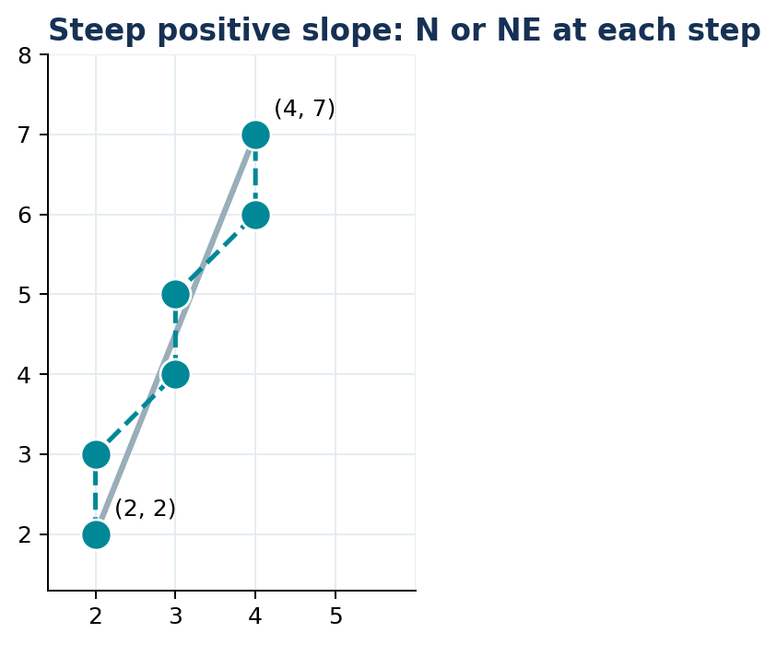
PIXELS: (2,2), (2,3), (3,4), (3,5), (4,6), (4,7)

Steep pseudocode
BRESENHAM_STEEP(x1, y1, x2, y2)
dx = x2 - x1; dy = y2 - y1
// Preconditions: dy > dx >= 0
d = 2*dx - dy
x = x1; y = y1
PLOT(x, y)
while y < y2
if d > 0
x = x + 1; y = y + 1
d = d + 2*(dx - dy) // NE
else
y = y + 1
d = d + 2*dx // N
PLOT(x, y)

11 Summary: identify the correct rule before calculating
Case | Driving axis | Candidate pixels | Start d | If d > 0 | If d ≤ 0
0 ≤ m ≤ 1 | x | E, NE | 2Δy−Δx | NE; +2(Δy−Δx) | E; +2Δy
m > 1 | y | N, NE | 2Δx−Δy | NE; +2(Δx−Δy) | N; +2Δx

Special cases: horizontal lines (Δy=0) advance only x; vertical lines (Δx=0) advance only y; a 45° positive diagonal (Δx=Δy) advances both. The formulas above assume the line moves rightward and upward.

Which information comes from the slide deck?
Slides 24–44 derive and demonstrate the midpoint decision algorithm; slides 47–48 summarize the two positive-slope cases. The next section adds general handling for negative slopes and reversed endpoints as a programming extension.

12 Instructor expansion: all directions / all octants
The same integer error principle works for negative slopes, reversed endpoints and all eight octants. Use absolute magnitudes of Δx and Δy plus signed direction steps. This is standard implementation knowledge added for your lab rather than a line-by-line reproduction of the source slides.
dx = |x₂−x₁| dy = |y₂−y₁|
sx = +1 if x₁ < x₂, otherwise −1
sy = +1 if y₁ < y₂, otherwise −1
error = dx − dy
At each plotted pixel, compute e2=2·error before modifying either coordinate. Depending on two comparisons, update x and/or y. The conditions are independent so diagonal moves can update both coordinates.
ALL_OCTANTS(x1, y1, x2, y2)
dx = abs(x2 - x1); dy = abs(y2 - y1)
sx = (x1 < x2) ? +1 : -1
sy = (y1 < y2) ? +1 : -1
err = dx - dy
loop
PLOT(x1, y1)
if x1 == x2 AND y1 == y2: stop
e2 = 2*err
if e2 > -dy: err = err - dy; x1 = x1 + sx
if e2 < dx: err = err + dx; y1 = y1 + sy
TEACHING NOTE Check the source’s tie rule separately when comparing implementations. Tie conventions can change a few selected pixels while leaving the line rasterization valid.

13 Complete C++ / OpenGL-FreeGLUT program
This standalone code draws four lines in different orientations using the all-octants version. It uses the compatibility OpenGL interface used in your existing lab materials and can be compiled with FreeGLUT configured in Code::Blocks.
#include <GL/glut.h>
#include <cstdlib> // abs

void bresenham(int x1, int y1, int x2, int y2)
{
int dx = abs(x2 - x1);
int dy = abs(y2 - y1);
int sx = (x1 < x2) ? 1 : -1;
int sy = (y1 < y2) ? 1 : -1;
int err = dx - dy;

glBegin(GL_POINTS);
while (true)
{
glVertex2i(x1, y1); // Plot the current integer pixel
if (x1 == x2 && y1 == y2) break;

int e2 = 2 * err;
if (e2 > -dy)
{
err -= dy;
x1 += sx;
}
if (e2 < dx)
{
err += dx;
y1 += sy;
}
}
glEnd();
}

void display()
{
glClear(GL_COLOR_BUFFER_BIT);
glPointSize(3.0f);

glColor3f(0.1f, 0.4f, 0.9f); // Shallow positive
bresenham(50, 60, 340, 190);

glColor3f(0.0f, 0.6f, 0.35f); // Steep positive
bresenham(420, 40, 520, 320);

glColor3f(0.9f, 0.35f, 0.2f); // Negative slope
bresenham(50, 340, 330, 230);

glColor3f(0.4f, 0.25f, 0.7f); // Reversed endpoints
bresenham(720, 340, 550, 150);
glFlush();
}

void init()
{
glClearColor(1.0f, 1.0f, 1.0f, 1.0f);
glMatrixMode(GL_PROJECTION);
glLoadIdentity();
gluOrtho2D(0, 800, 0, 400);
}

int main(int argc, char** argv)
{
glutInit(&argc, argv);
glutInitDisplayMode(GLUT_SINGLE | GLUT_RGB);
glutInitWindowSize(900, 500);
glutCreateWindow("Bresenham - All Octants");
init();
glutDisplayFunc(display);
glutMainLoop();
return 0;
}
Lab reminder: OpenGL here is only plotting the discrete pixels returned by the algorithm; GL_LINES is not used, because the educational goal is to generate those pixels yourself.

14 Classroom delivery guide
Time | What to teach | Activity / check
0–10 min | Real line vs raster pixel grid | Sketch a diagonal on squared paper
10–20 min | E and NE, midpoint M | Students point to closest candidate
20–40 min | Line equation and F(x,y) | Convert y=mx+B into implicit form
40–55 min | Initial d₀; scaling by 2 | Ask why the sign is unchanged
55–70 min | Derive E and NE updates | Cancel terms step by step
70–85 min | Solve slide example (4,5)→(7,7) | Students complete decision table
85–100 min | Steep case and example | Show N/NE and swapped axes
100–120 min | Code + discussion | Modify endpoints and predict pixels

Common mistakes and how to correct them
- Incorrect slope: m = Δy/Δx, not Δx/Δy. Check whether the line is shallow or steep before choosing a table.
- Confusing “candidate” and “plotted pixel”: the current d decides the next pixel, then d updates for the next iteration.
- Updating d before choosing: use the current d for the current decision and only afterward apply the corresponding increment.
- Forgetting the scaled parameter: once d has been multiplied by 2, the update must also use 2Δy or 2(Δy−Δx).
- Making the wrong tie decision: this lecture uses d≤0 for E (shallow) or N (steep).
- Using shallow positive-slope code on a negative or steep line: either transform the octant or use the generalized implementation.
- Plotting too few points: include both starting and ending endpoints.

15 Short questions / oral viva
- Why is Bresenham an incremental line algorithm?
- What do E and NE represent?
- What is the midpoint and why test it?
- How is F(x,y)=ax+by+c related to y=mx+B?
- Why is multiplying the decision expression by 2 valid?
- For 0≤m≤1, what do d>0 and d≤0 mean?
- Where do the +2Δy and +2(Δy−Δx) updates come from?
- What changes when slope exceeds 1?
- Can different tie-breaking rules produce different valid raster patterns?
- How would you handle a negative slope in code?

16 Student practice problems
Require the full board-style solution: calculate Δx, Δy and m; choose the case; find initial d; precompute both updates; show every chosen pixel in a table; identify the final pixel sequence.
Problem | Endpoints | Case to recognize
A | (1,2) to (7,5) | Shallow, positive
B | (3,1) to (6,9) | Steep, positive
C | (2,4) to (10,4) | Horizontal special case
D | (5,2) to (5,8) | Vertical special case
E | (2,8) to (9,3) | Negative slope: extension

Instructor answer check — Problem A
Δx=6, Δy=3, m=0.5. Initial d=2(3)−6=0. E increment +6; NE increment 2(3−6)=−6. Under the slide convention, ties choose E.
From | d | Move | Plot | Next d
(1,2) | 0 | E | (2,2) | 6
(2,2) | 6 | NE | (3,3) | 0
(3,3) | 0 | E | (4,3) | 6
(4,3) | 6 | NE | (5,4) | 0
(5,4) | 0 | E | (6,4) | 6
(6,4) | 6 | NE | (7,5) | end

Instructor answer check — Problem B
Δx=3, Δy=8, m=8/3 > 1. Initial d=6−8=−2; N update +6; NE update 2(3−8)=−10.
From | d | Move | Plot | Next d
(3,1) | −2 | N | (3,2) | 4
(3,2) | 4 | NE | (4,3) | −6
(4,3) | −6 | N | (4,4) | 0
(4,4) | 0 | N | (4,5) | 6
(4,5) | 6 | NE | (5,6) | −4
(5,6) | −4 | N | (5,7) | 2
(5,7) | 2 | NE | (6,8) | −8
(6,8) | −8 | N | (6,9) | end

